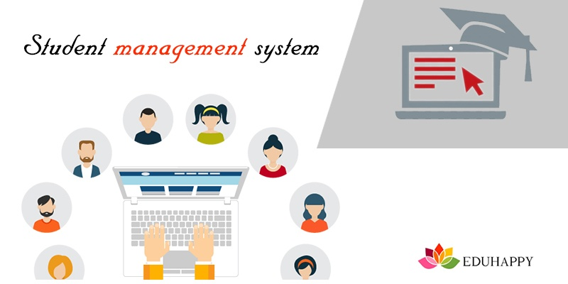

Mahatma Education Society’s

**Pillai College of Arts, Commerce & Science**

# (Autonomous)

**Affiliated to University of Mumbai**

NAAC Accredited 'A' grade (3 cycles) Best College Award by University of Mumbai

ISO 9001:2015 Certified

**CERTIFICATE**

*This is to certify that Mr. /Miss. Shreya Bhattacharjee of* ***T.Y B.Sc. C.S. Semester V*** *has completed the project work in the Subject of* ***java framework****during the academic year 2022-23 under the guidance of Prof****. _Manasi Rajesh Khedekar*** *being the partial requirement for the fulfillment of the curriculum of* ***Degree of Bachelor of Science in Computer Science****,* ***University of Mumbai****.*

***Place:***

***Date:***

*Name & Signature of faculty Name & Signature of external*

*Name & Signature of Co-ordinator*

Dr. K.M. Vasudevan Pillai Campus, Sector 16, New Panvel - 410206. Tel : 27456100 / 1700 | Fax : 27483208 | Website : [www.pcacs.ac.in](http://www.pcacs.ac.in/)

1.Abstract

 Student Information Management System (SIMS) **provides a simple interface for maintenance of student information**. It can be used by educational institutes or colleges to maintain the records of students easily.

2.Introduction

***"Student Management System (SMS) is a solution tool that is designed to track, maintain and manage all the data generated by a School, including the grades of a student, their attendance, their interpersonal activities records, etc.,"***

***SMS acts as the bottom line database to store all the day-to-day school operations, maintain the proper records of the past few decades, regulate the various operation modules, managing the critical tasks, efficiently handling the administrative processes***

***a comprehensive system for information management of the students.***

3.Software specification

NETBEANS:

NetBeans IDE is a free, open source, integrated development environment (IDE) that enables you to develop desktop, mobile and web applications. The IDE supports application development in various languages, including Java, HTML5, PHP and C++. The IDE provides integrated support for the complete development cycle, from project creation through debugging, profiling and deployment. The IDE runs on Windows, Linux, Mac OS X, and other UNIX-based systems.

The IDE provides comprehensive support for JDK 7 technologies and the most recent Java enhancements. It is the first IDE that provides support for JDK 7, Java EE 7, and JavaFX 2. The IDE fully supports Java EE using the latest standards for Java, XML, Web services, and SQL and fully supports the GlassFish Server, the reference implementation of Java EE.

Xaampp:

XAMPP is an abbreviation where ***X stands for Cross-Platform, A stands for Apache, M stands for***[***MYSQL***](https://www.javatpoint.com/mysql-tutorial)***, and the Ps stand for PHP and Perl***, respectively. It is an open-source package of web solutions that includes Apache distribution for many servers and command-line executables along with modules such as Apache server, [MariaDB](https://www.javatpoint.com/mariadb-tutorial), PHP, and Perl.

XAMPP helps a local host or server to test its website and clients via computers and laptops before releasing it to the main server. It is a platform that furnishes a suitable environment to test and verify the working of projects based on Apache, Perl, MySQL database, and PHP through the system of the host itself.

Project Overview/Structure

* CRUD stands for Create, Read/Retrieve, Update and Delete and these are the four basic operations that we perform on persistence storage. CRUD is data-oriented and the standardized use of HTTP methods.
* **POST**: Creates a new resource
* **GET**: Reads/Retrieve a resource
* **PUT**: Updates an existing resource
* **DELETE**: Deletes a resource

**CRUD operations**over the Student Management , let us consider we are creating a MENU DRIVER program that will have a student list. The list will hold the student object that contains student details. Your menu should have 4 basic operations like Add, Search, Remove, and Show details of the student.

In this project “Student Management System” we are having total 8 entities where ID is an primary key.

The entities which are present are

1. Id(**primary key)**

2. Student name

3. Student course

4. Student address

5. Student contact no

6. Student roll no

7. Student marks

8. Student remark

Code:

**ShowAll.jsp**

<%@page contentType="text/html" pageEncoding="UTF-8"%>

<%@ taglib prefix="c"

uri="http://java.sun.com/jsp/jstl/core" %>

<!DOCTYPE html>

<html>

<head>

<style>

body{

background-color: lightgrey;

}

</style>

<meta http-equiv="Content-Type" content="text/html; charset=UTF-8">

<title>JSP Page</title>

<script src="https://ajax.googleapis.com/ajax/libs/jquery/1.12.4/jquery.min.js"></script>

<script>

$(document).ready(function(){

$("#deleteStudent").hide();

$("#updateStudent").hide();

$("#update").click(function(){

$("#updateStudent").show();

$("#deleteStudent").hide();

});

$("#delete").click(function(){

$("#deleteStudent").show();

$("#updateStudent").hide();

});

});

</script>

</head>

<body>

All Students: <br>

<c:forEach var="std" items="${studentList}">

Student ID: ${std.id} <br>

Student Name: ${std.name} <br>

Student Coursename: ${std.coursename} <br>

Student Address: ${std.address}<br>

Student Contactno: ${std.contactno}<br>

Student Emailid: ${std.emailid} <br>

Student Rollno: ${std.rollno}<br>

Student Marks: ${std.marks}<br>

Student Remarks: ${std.remarks} <br>

-------------------------------------<br>

</c:forEach>

<form action="StudentController" method="POST">

Update: <input type="checkbox" id="update"> Delete: <input type="checkbox" id="delete" onclick="document.getElementById('name').disabled=this.checked;document.getElementById('coursenameupdate').disabled=this.checked;document.getElementById('addressupdate').disabled=this.checked;document.getElementById('contactnoupdate').disabled=this.checked;document.getElementById('emailidupdate').disabled=this.checked;document.getElementById('rollnoupdate').disabled=this.checked;document.getElementById('marksupdate').disabled=this.checked;document.getElementById('remarksupdate').disabled=this.checked;"><br><br>

<select name="id">

<c:forEach items="${studentList}" var="student">

<option value="${student.id}">${student.id}</option>

</c:forEach>

</select>

<br>

Update Name: <input id="name" type="text" name="name"><br><br>

Update Coursename: <input id="coursenameupdatee" type="text" name="coursenameupdate"> <br><br>

Update Address: <input id="addressupdatee" type="text" name="addressupdate"> <br><br>

Update Contactno: <input id="contactnoupdatee" type="text" name="contactnoupdate"> <br><br>

Update Emailid: <input id="emailidupdatee" type="text" name="emailidupdate"> <br><br>

Update Rollno: <input id="rollnoupdatee" type="text" name="rollnoupdate"> <br><br>

Update Marks: <input id="marksupdatee" type="text" name="marksupdate"> <br><br>

Update Remarks: <input id="remarksupdatee" type="text" name="remarksupdate"> <br><br>

<button type="submit" id="updateStudent" name="updateStudent"> Update</button> <br> <br>

<button type="submit" id="deleteStudent" name="deleteStudent"> Delete </button>

</form>

</body>

</html>

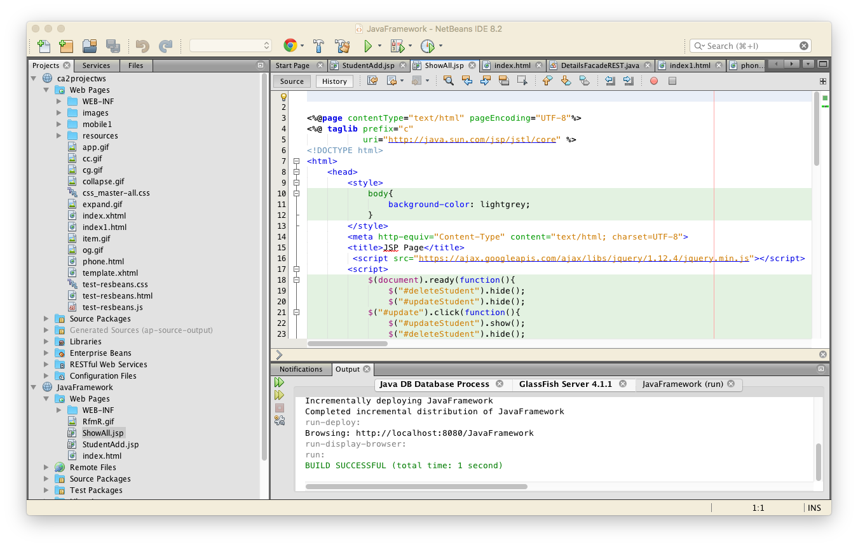

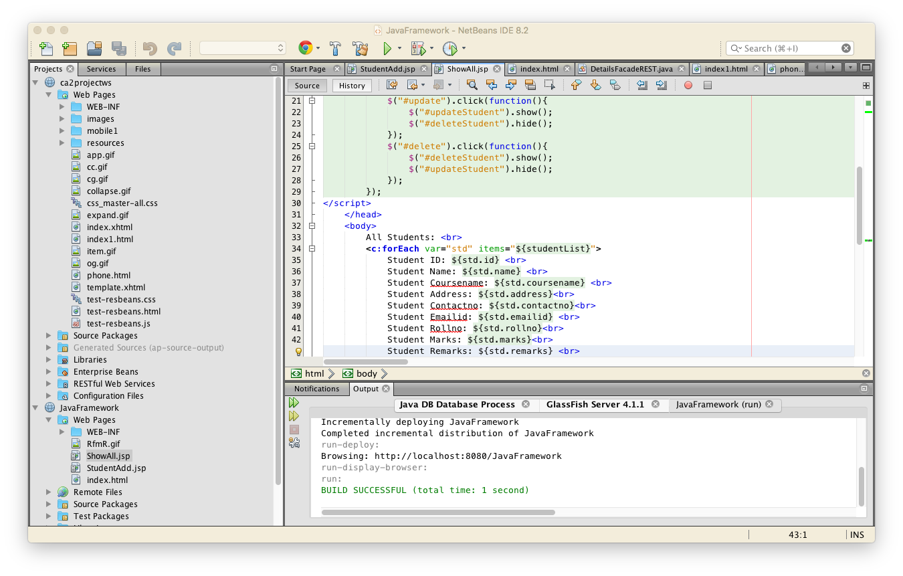

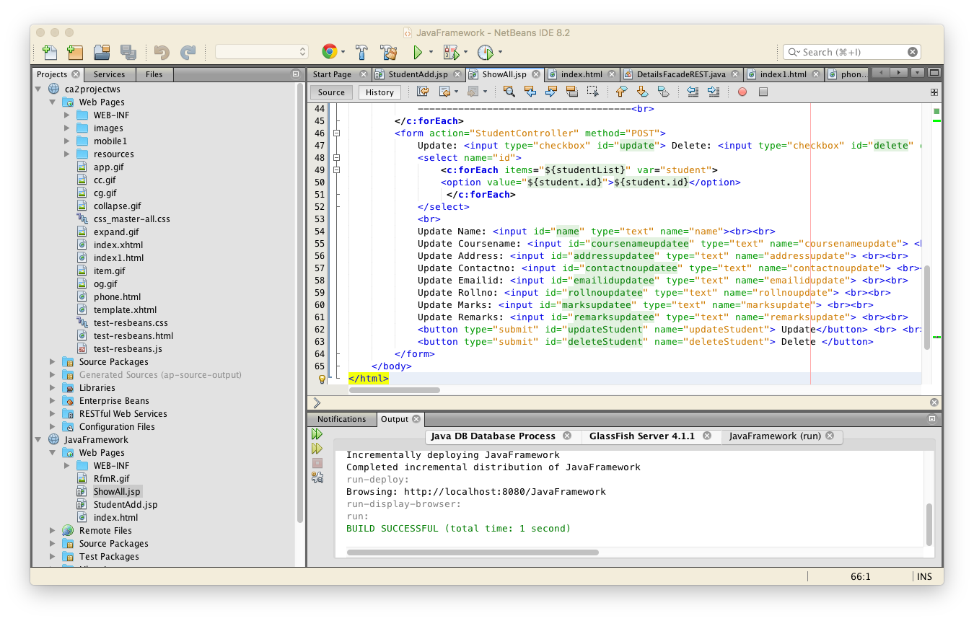

StudentAdd.jsp

<%@page contentType="text/html" pageEncoding="UTF-8"%>

<!DOCTYPE html>

<html>

<head>

<meta http-equiv="Content-Type" content="text/html; charset=UTF-8">

<title>Student Details</title>

<style>

body{

margin: 0 auto;

background-image: url("RfmR.gif");

background-repeat: no-repeat;

background-size: 100% 800px;

}

h3{

color:windowtext;

}

h1{

color:peachpuff;

}

</style>

</head>

<body>

<form method="GET" action="StudentController">

<b> <h1>STUDENT MANAGEMENT SYSTEM</h1></b>

<h3>Student Name:<input type="text" name="name"placeholder="Name"><br></h3>

<h3>Student Course Name:<input type="text" name="coursename"placeholder="Course Name"><br></h3>

<h3>Student Address:<input type="text" name="address" placeholder="Address"><br></h3>

<h3>Student Contact No:<input type="text" name="contactno"placeholder="Contact No"><br></h3>

<h3>Student Email Id:<input type="text" name="emailid"placeholder="Email Id"><br></h3>

<h3>Student Roll No:<input type="text" name="rollno"placeholder="Roll No"><br></h3>

<h3>Student Marks:<input type="text" name="marks"placeholder="Total Marks"><br></h3>

<h3>Student Remarks:<input type="text" name="remarks"placeholder="Remarks"><br></h3>

<input type="submit" name="addStudent" value="Add"><br><br>

</form>

<form action="StudentController" method="POST">

<input type="submit" name="showStudent" value="Show"><br>

</form>

</body>

</html>

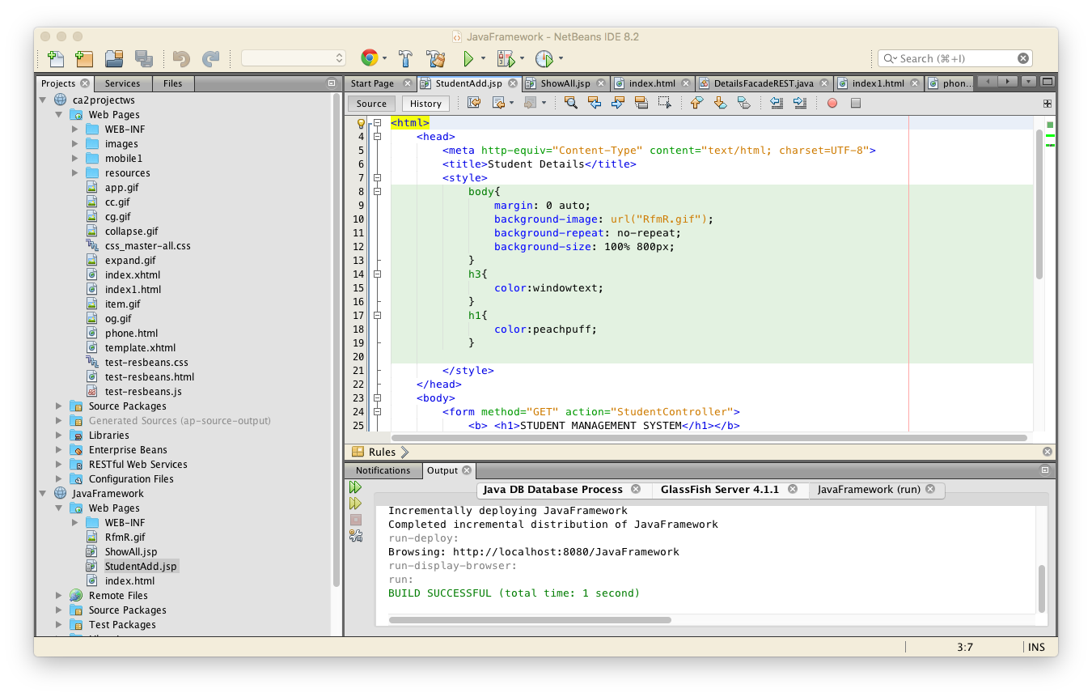

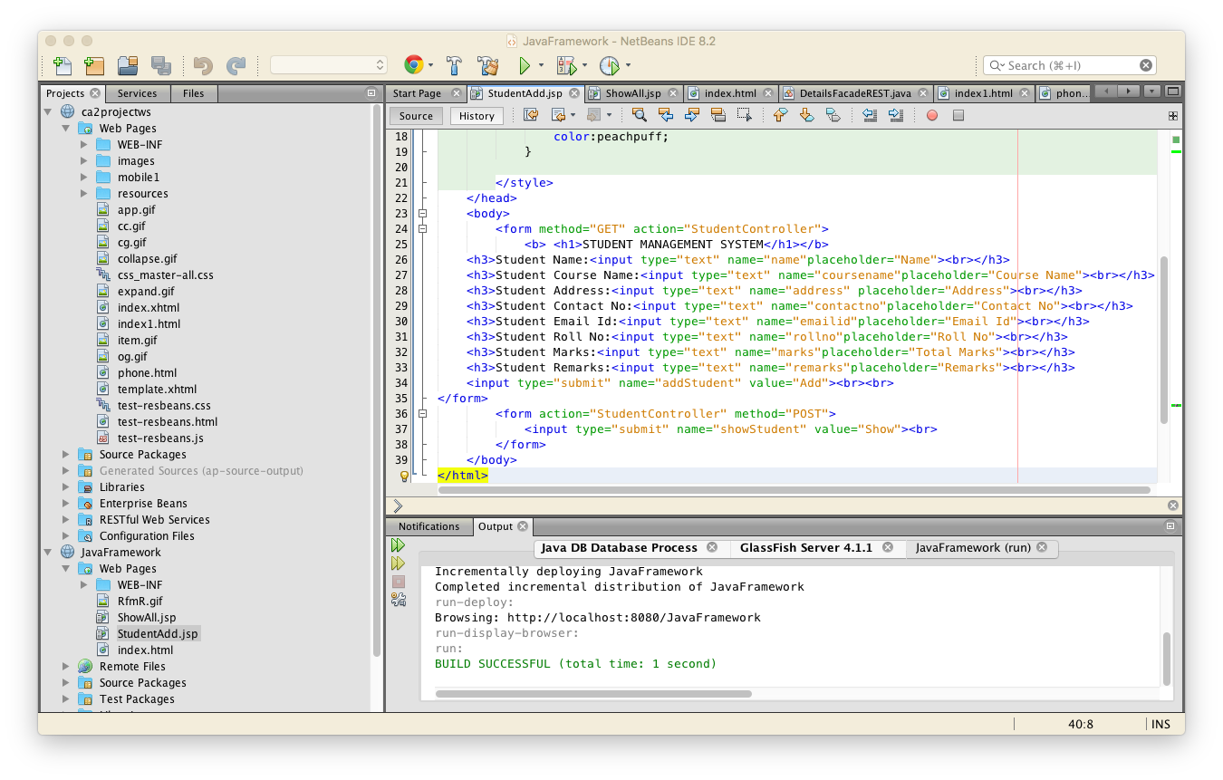

OUTPUT:

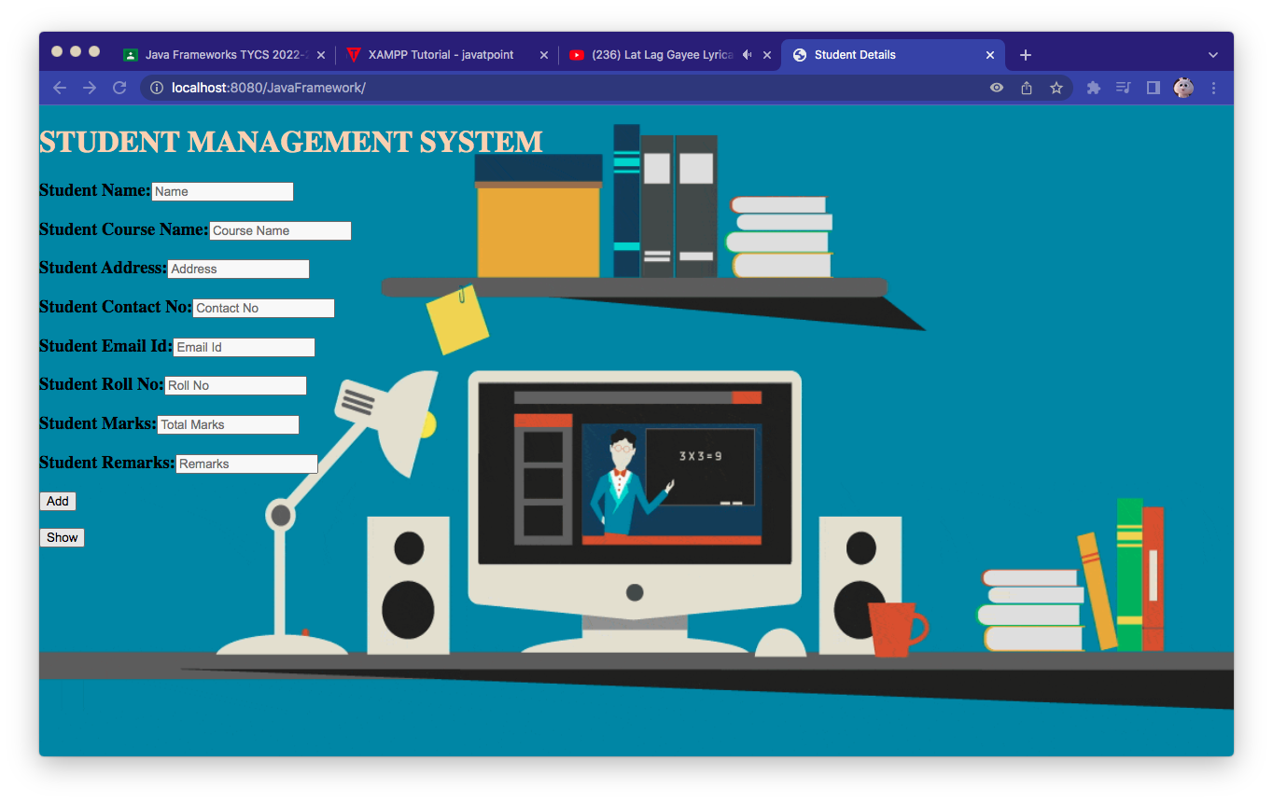

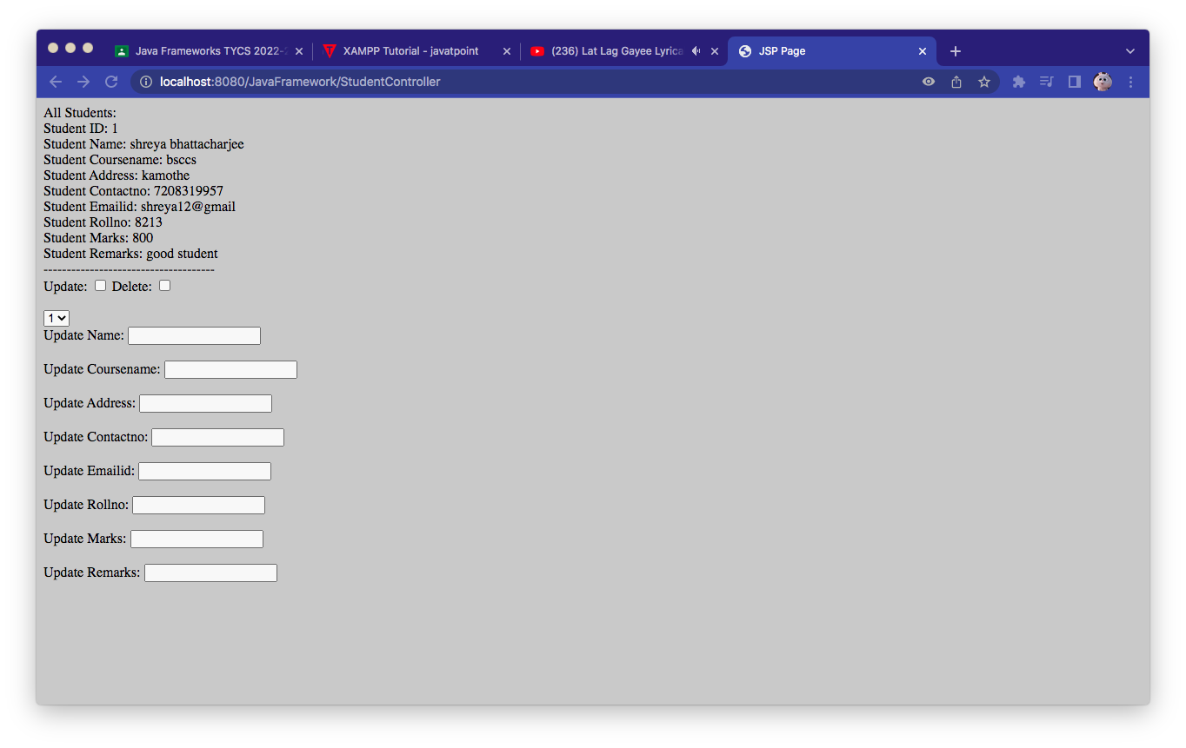

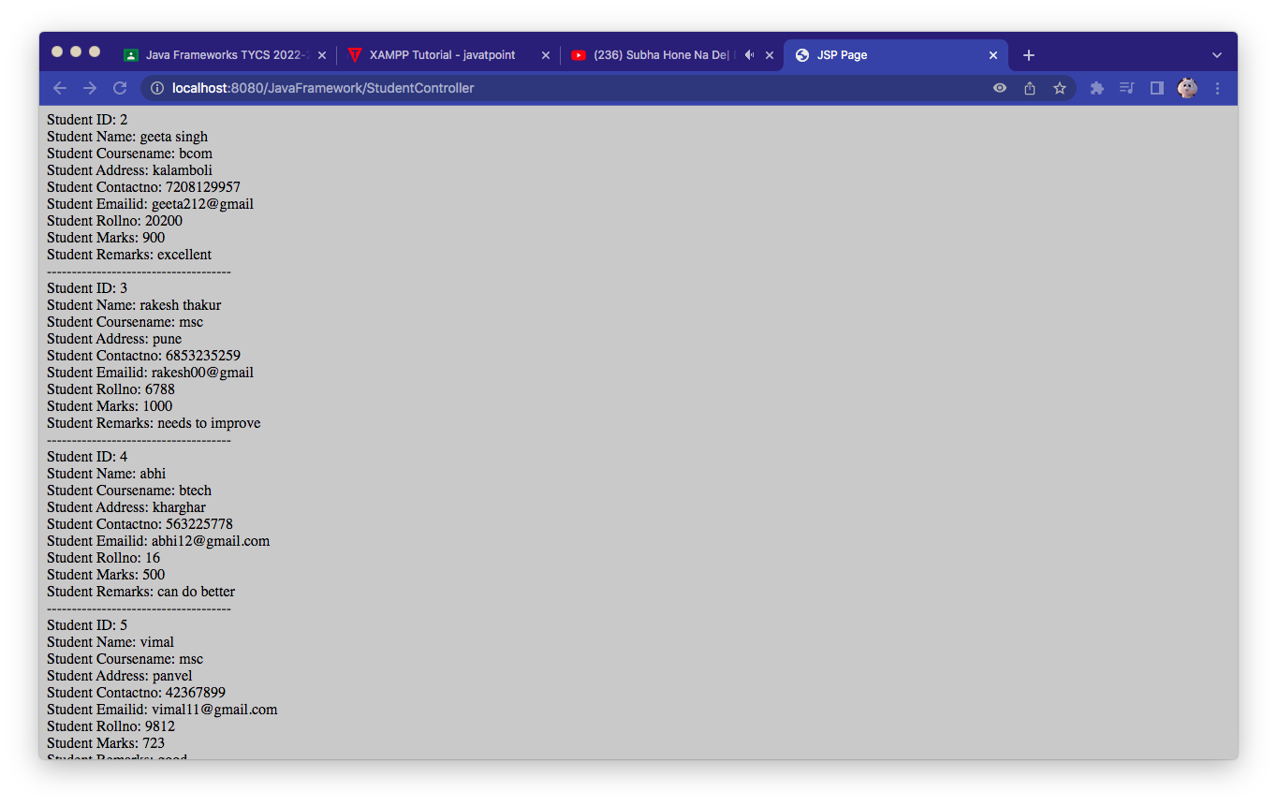

Updating data

